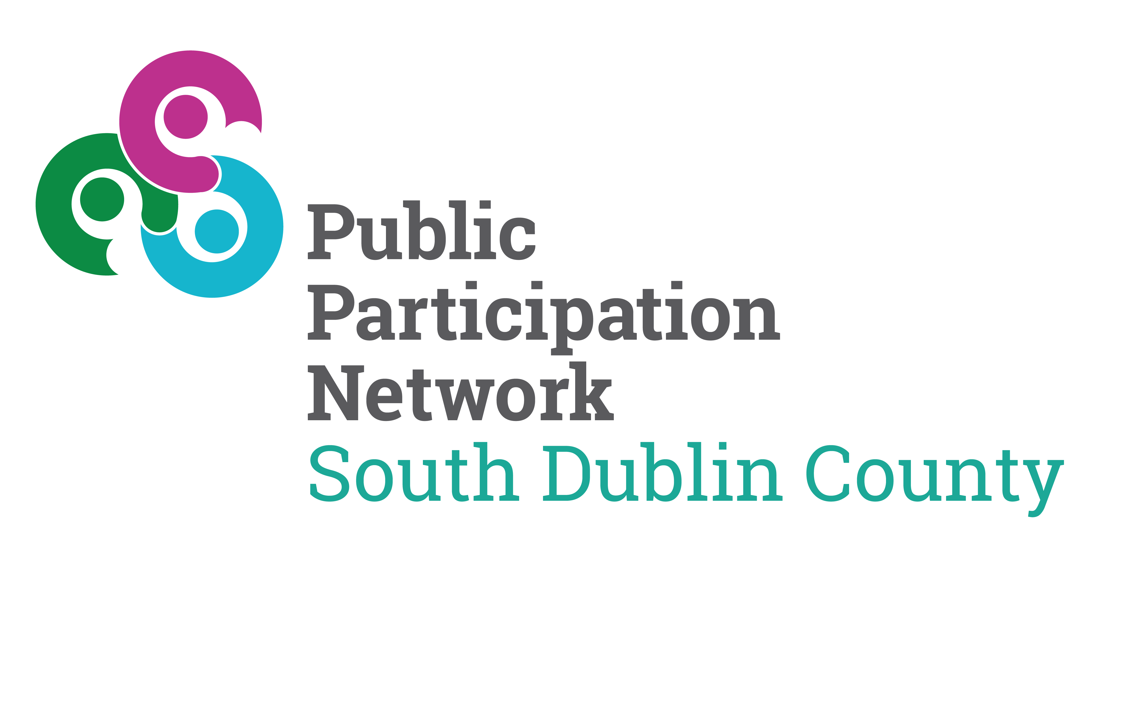

Complaints Form

1. About You
Full Name
Address
Telephone Number
Email address

Preferred method of communication
☐ Email ☐ Phone ☐ Post
Are you making this complaint on behalf of someone else?
☐ No ☐ Yes
If yes, please provide their name and confirm that you have their permission to act on their behalf.

2. About Your Complaint
Please briefly describe your complaint.
(Include relevant dates, times and any people or services involved.)

3. What Outcome Are You Seeking?
Please tell us what you would like to happen as a result of making this complaint.
(For example: an explanation, an apology, a change to how something is done.)

4. Supporting Information
Please list or attach any documents or information that may help us understand your complaint.

5. Support and Accessibility Needs
Do you have any specific needs that we should be aware of when communicating with you? (For example: language support, accessibility requirements.)
☐ No ☐ Yes (please specify)

6. Privacy and Data Protection
The information you provide on this form is collected for the purpose of handling your complaint.
Your information will be used only to assess, investigate and respond to your complaint and will be handled in line with the South Dublin County Public Participation Network Data Protection Policy. A copy of this policy is available on our website.

7. Declaration
I confirm that the information provided is accurate to the best of my knowledge.
Signature (if submitting by post):
Date:

8. How to Submit This Form
You can submit this form in any of the following ways:
- Online via the complaints form on our website www.sdcppn.ie
- By email to info@sdcppn.ie with Complaint in the title.
- By post to:
South Dublin County Public Participation Network
Ace Enterprise Park, Bawnogue Rd, Clondalkin, Dublin, D22 P6E8.

